DAT 610 Exercise Six
Additional Materials

Exercise Six requires some additional information to help you understand what is going on. This document seeks to present the information in a way that will allow you to apply it to future work. Please pay attention to the section that deals with missings in creating the average losses. After the first section, there is a section on how to interpret regression output in R.
#Exercise 6, importing the data:
iihs_data <- read.csv(“~/Desktop/iihs_data_for_EX_6.csv”)
View(iihs_data)
model <- princomp(~.,iihs_data[1:75,3:8], na.action=na.omit)
summary(model)
screeplot(model)
#average loss over all categories
#except we have a problem with a lot of missing values. What do we do?
#adjust denominator for number of obs
#use rowMeans with na.rm for handling missings
attach(iihs_data)
my_data=data.frame(Collision., Property.damage., Comprehensive., Personal.injury., Medical.payment., Bodily.injury.)
iihs_data$avgloss <- rowMeans(my_data, na.rm=TRUE)
detach(iihs_data)
#now do the buy outcome variable
iihs_data_tr <- transform(iihs_data, Buy = as.numeric(iihs_data$avgloss < 100))
View(iihs_data_tr)
#linear regression model
attach(iihs_data_tr)
lm_model=lm(Buy ~ Collision. + Property.damage. + Comprehensive. + Personal.injury. + Medical.payment. + Bodily.injury.)
summary(lm_model)
#logistic model
lg_model=glm(Buy ~ Collision. + Property.damage. + Comprehensive. + Personal.injury. + Medical.payment. + Bodily.injury.,family = "quasibinomial",na.action=na.omit,control = list(maxit = 50))
summary(lg_model)
#models with average loss
lm_model2=lm(Buy ~ avgloss + Collision. + Property.damage. + Comprehensive. + Personal.injury. + Medical.payment. + Bodily.injury.)
summary(lm_model2)

lg_model2=glm(Buy ~ Collision. + Property.damage. + Comprehensive. + Personal.injury. + Medical.payment. + Bodily.injury. + avgloss,family = "quasibinomial",na.action=na.omit,control = list(maxit = 50))
summary(lg_model2)
#simplest:
lg_model2=glm(Buy ~ avgloss,family = "quasibinomial",na.action=na.omit,control = list(maxit = 50))
summary(lg_model2)
#sort
sorted_data <- iihs_data_tr[order(avgloss),]

Interpreting Regression Output in R

R spits out some funny stuff when you run a regression. It can be tangled and hard to understand. Here is a summary of R’s lm() function output.

Models
Here is the first linear regression model’s output from the exercise on PCA in the car model risk scenario:

lm_model=lm(Buy ~ Collision. + Property.damage. + Comprehensive. + Personal.injury. + Medical.payment. + Bodily.injury.)
summary(lm_model)

#Call:
lm(formula = Buy ~ Collision. + Property.damage. + Comprehensive. +
Personal.injury. + Medical.payment. + Bodily.injury.)

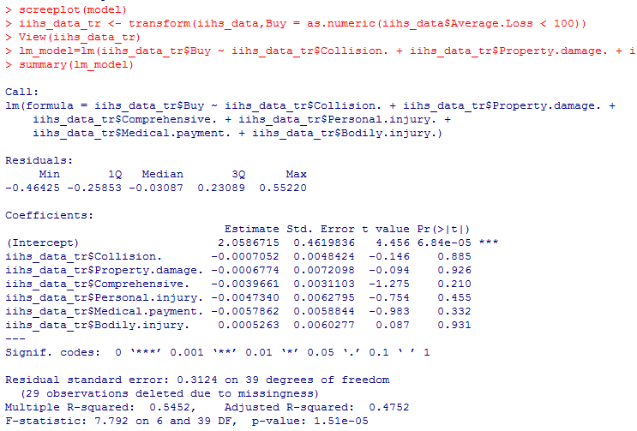

When you first learned stats, were you taught the regression equation?

y = ß₀ + ß₁x₁ + ß₂x₂ + … + ß_{z}x_{z} + e

That is, the outcome y is dependent on the starting point (the y-intercept, or ß₀) plus the combined contributions of each covariate (x₁ through x_{z}) plus an error term. This is the standard linear regression equation. Each of the covariates is represented by a coefficient, which are the betas. It is a linear relationship, meaning that when you add up everything on the right side, y moves in a predictable, stepwise manner on the left side. This means that all linear regressions can be plotted as a line through a point cloud of observations₍₁₎:

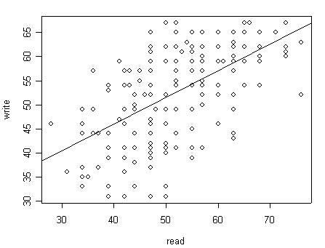
Note: This is not from our data set.

The y-intercept is the start point of the line, which is the leftmost place where it emerges from the
y-axis. The slope is the combination of all of the coefficients. The error term is “the combined effect of the omitted variables” from the relationship.₍₂₎

For this example, the equation in our exercise is as follows:

Buy = Collision. + Property.damage. + Comprehensive. +
Personal.injury. + Medical.payment. + Bodily.injury.

In math terms, that translates to the following:

y = 2.47 - 0.0058x₁ + 0.0099x₂ - 0.0041x₃ + 0.0019x₄ - 0.012x₅ -0.0066x₆ + e

Do you see where all the numbers came from (the R output at the top)? The intercept is the first value of the Estimate column, next to where it says (Intercept). The other coefficients, the betas, came from each item in turn going down that list.

We are going to explore what this all means.

Coefficients

Here is how to interpret the coefficients. “Each unit increase in y is dependent on a 0.0058 decrease in x₁, a 0.0099 increase in x₂...” etc. You may alternatively state that, for each unit increase in x₁, y will decrease 0.0058. For our purposes, you could say that “for each unit increase in collision payouts, there is a 0.0058 decrease in the likelihood to recommend buying that make of car.” And then, explain the buy recommendation in terms of each beta coefficient on each x.

Y is dependent on the x’s. The x’s are independent. They vary on their own, independently. As such, y is affected because x changes. This is correlation. You have heard that correlation is not equal to causation. That means that y may vary with changes in x, but directionality is not presumed. Y could vary because of the x’s. The x’s could vary because y appears to change. We do not know. All we know is the suspected linear relationship of y = mx + b, the classic equation of a line, which is the same exact thing as the classical linear regression equation:

y = ß₀ + ß₁x₁ + ß₂x₂ + … + ß_{z}x_{z} + e

Significance

When building a model, we sometimes use the exhaustive method to look at all covariates simultaneously and then remove the ones not found to be significantly associated with the outcome. There are many approaches to model building. This is just one.

In our original model, only Medical.payment was significant. What does that mean? It means that we could, rationally, pare down the model to just the significant covariate since the others seem to cloud the effect. We could rewrite the model as follows:

Call:
lm(formula = Buy ~ Medical.payment.)

Residuals:
Min 1Q Median 3Q Max
-0.64788 -0.34498 0.08644 0.31497 0.71233

Coefficients:
Estimate Std. Error t value Pr(>|t|)
(Intercept) 1.74520 0.17307 10.084 1.15e-15 ***
Medical.payment. -0.01143 0.00140 -8.162 5.40e-12 ***
---
Signif. codes: 0 ‘***’ 0.001 ‘**’ 0.01 ‘*’ 0.05 ‘.’ 0.1 ‘ ’ 1

Residual standard error: 0.3574 on 76 degrees of freedom
(32 observations deleted due to missingness)
Multiple R-squared: 0.4671, Adjusted R-squared: 0.4601
F statistic: 66.61 on 1 and 76 DF, p value: 5.395e-12

Now, for every unit increase in the medical payment insurance payout for a type of car, we expect a
-0.011 decrease in the buy recommendation. The less a type of car pays out for medical claims, the more likely the risk model is to recommend that car as one to buy.

What is significance? Significance is the likelihood that the null hypothesis is false. The null hypothesis in this case is that there is no relationship between medical payouts and the buy recommendation. Since we have covariates that are significantly associated with the outcome, we reject the null hypothesis in favor of the alternative hypothesis, which is that there is a relationship between medical payouts and the buy recommendation for types of cars.

Significance = Reject the null hypothesis.
Non-significance = Accept the null hypothesis.

The null hypothesis is that there is no relationship between y and the x’s—i.e., that the dependent variable is not dependent on the independent variables.

The t statistic is the test of that covariate against the null. The p value is whether that test is significant.

Two-tailed significance is usually measured at p ≤ 0.05. In the interest of time, p values will not be explained in this write-up, but they are fascinating.₍₃₎

Model Fitness

We can assess the model’s fitness a number of ways with the output. The easiest way (although not the most accurate) is to look at the R² and adjusted R². The R² tells you how much of y’s variance is explainable by the covariates. It is a measure of the strength of association between y and the x’s.₍₄₎

The next way is to look at the F statistic for the model. A large F indicates that the model is performing better than random noise as a predictor of the outcome.₍₅₎ And the p value tells you whether the F test of the model against random noise is significant. A large value for F and a p ≤ 0.05 indicates overall good model fitness. Good model fitness means that the independent variable explains the dependent variable well. Although, again, this does not imply directionality in a mathematical sense. We still only know there is a significant correlation.

The Difference Between Linear and Logistic Regression

Please note that the linear model for a buy recommendation is totally wrong! A buy recommendation is a yes or a no. That is a binary outcome. Linear models typically look like the example scatterplot above. Y values are in a continuous range, as are the x values. Our model looks like this:

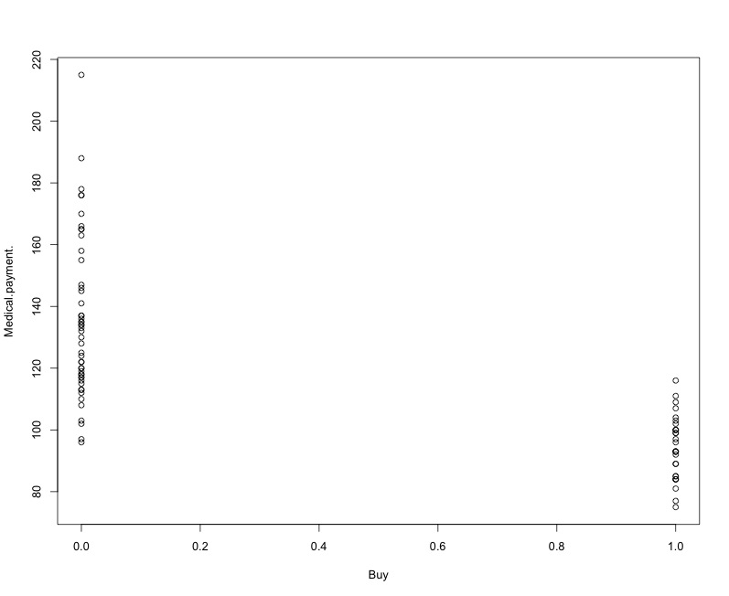

The buy variable is clearly a 0/1 outcome. When you use a linear relationship on a binary outcome like this, you lose information and give a distorted view of the relationship because the linear model tends to underestimate large variance.₍₆₎ Variance in a probability situation would follow a distribution rather than being grouped at the extremes. With no values other than 0 or 1 in the outcome, any in-between probabilities are going to be misestimated. Instead, we should use a logistic regression, which allows us to ascertain the probability of an event, given an underlying probability distribution (i.e., use logistic regression on a binary outcome).

#Call:
glm(formula = Buy ~ Medical.payment., family = "quasibinomial",
na.action = na.omit, control = list(maxit = 50))

Deviance Residuals:
Min 1Q Median 3Q Max
-2.11200 -0.26389 -0.00545 0.23684 2.06557

Coefficients:
Estimate Std. Error t value Pr(>|t|)
(Intercept) 21.91062 3.89345 5.628 2.92e-07 ***
Medical.payment. -0.20619 0.03658 -5.637 2.81e-07 ***
---
Signif. codes: 0 ‘***’ 0.001 ‘**’ 0.01 ‘*’ 0.05 ‘.’ 0.1 ‘ ’ 1

(Dispersion parameter for quasibinomial family taken to be 0.5131742)

Null deviance: 102.945 on 77 degrees of freedom
Residual deviance: 34.987 on 76 degrees of freedom
(32 observations deleted due to missingness)
AIC: NA

Number of Fisher Scoring iterations: 7

You can see that the effect of medical payouts on the buy recommendation is instead -0.2 rather than being underestimated as -0.01.

Conclusion

Hopefully, this little primer helps explain regression output more clearly. It’s an important skill to have. The reason is that we use regression to explore whether there are provable relationships between variables. Although we are engaged in learning PCA, regression concepts are very important in explaining what is going on in these systems.

References

- http://www.ats.ucla.edu/stat/r/faq/scatte1.gif
- http://www.stat.berkeley.edu/~census/epsilon.pdf
- http://en.wikipedia.org/wiki/P-value
- http://www.ats.ucla.edu/stat/stata/output/reg_output.htm
- http://stats.stackexchange.com/questions/59250/how-to-interpret-the-output-of-the-summary-method-for-an-lm-object-in-r
- http://stats.stackexchange.com/questions/29325/what-is-the-difference-between-linear-regression-and-logistic-regression

